**RESTAURANT SCREEN**



Search Food





What do you want to eat today?

Save 15% at these restaurants with your exclusive ELEAT card

**MENU BAR WITH ICONS AND WORDS**

**FOR HOME, RESTAURANTS & ABOUT SCREENS**

Filter Search

Results





Dolce Vita Gourmet Café

Cakes, Pastries, Coffee, Salads & More

Movie Towne, POS & C3 Centre, San Fernando

more...

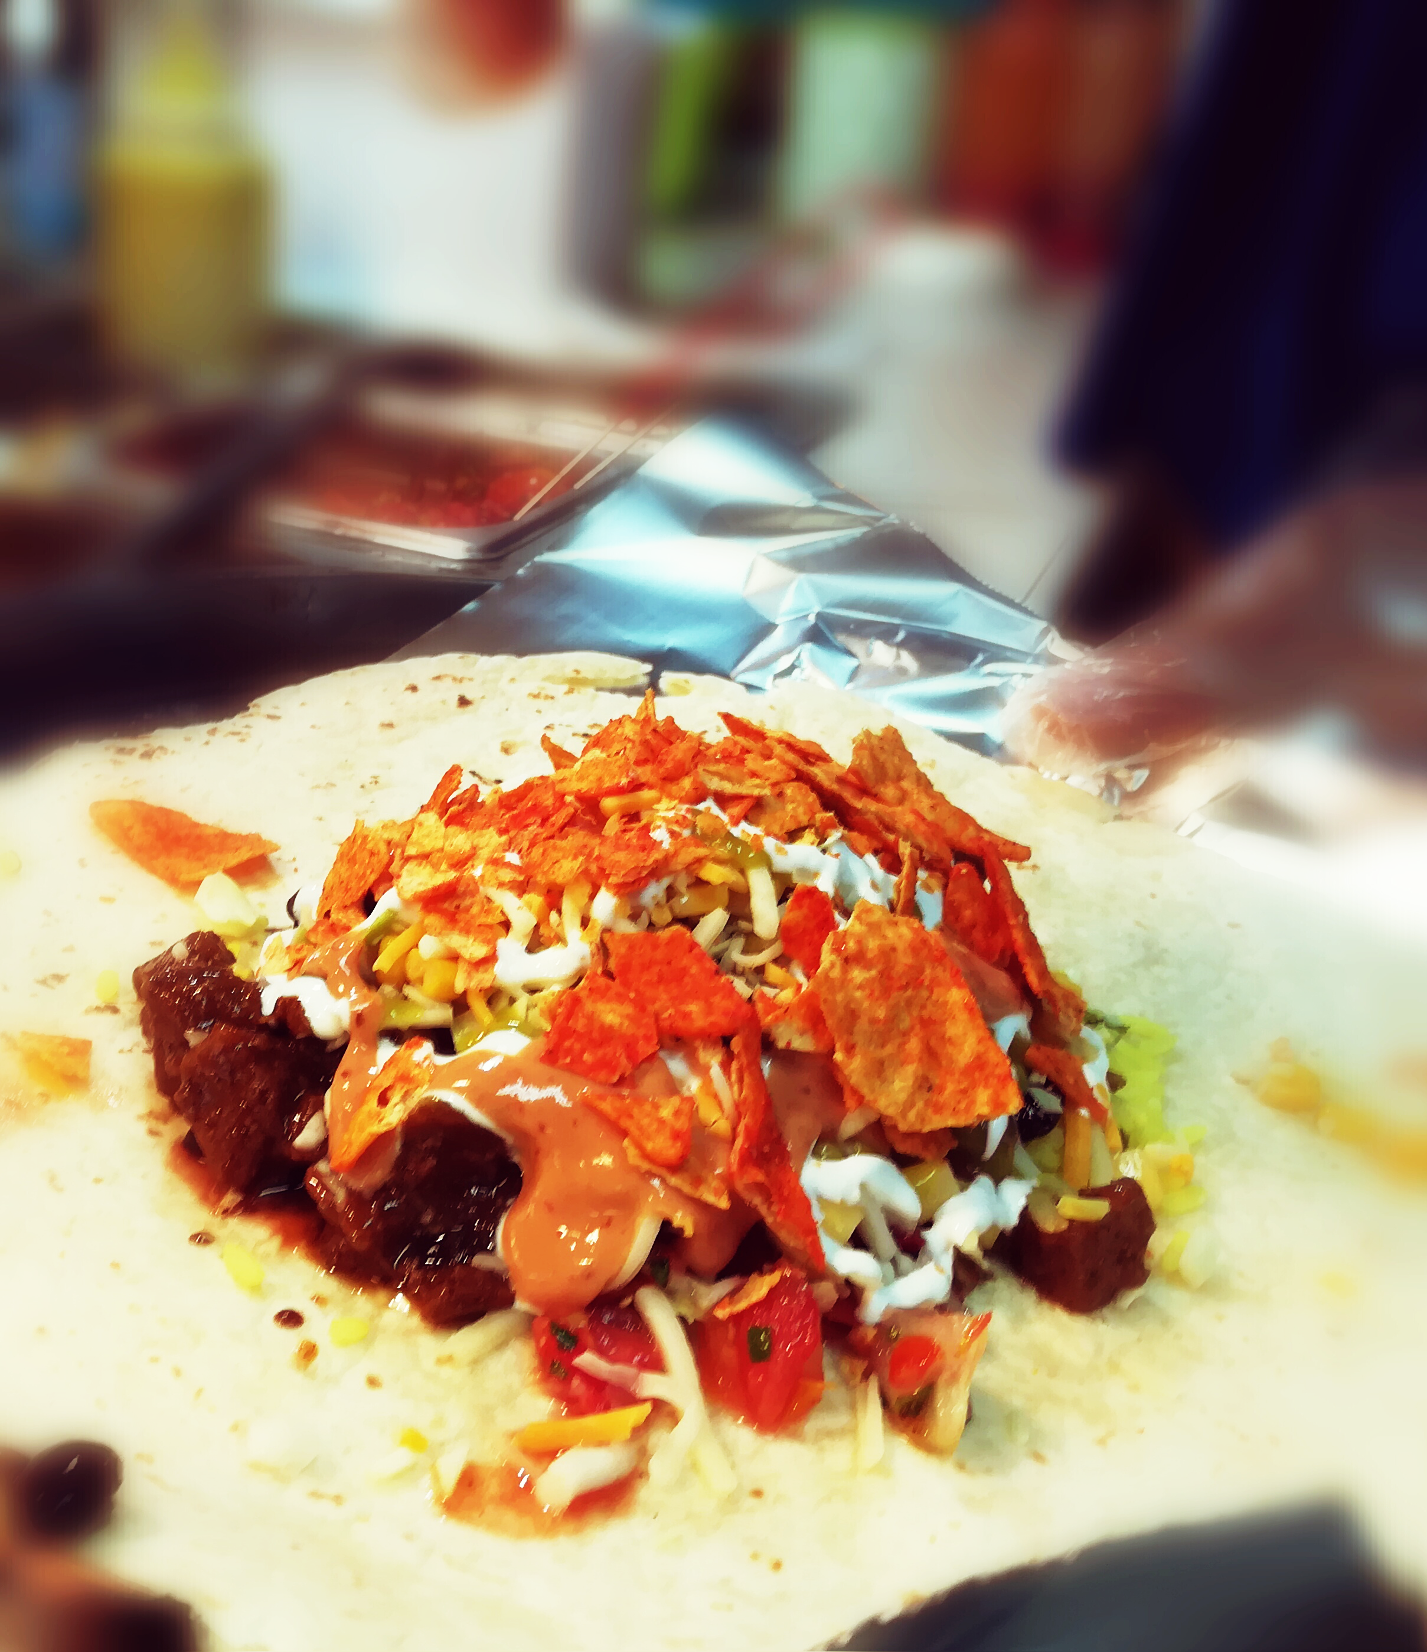

Chimichanga Mexican Grill

Tacos, Enchiladas & Burritos

The Crossing, San Fernando

more...

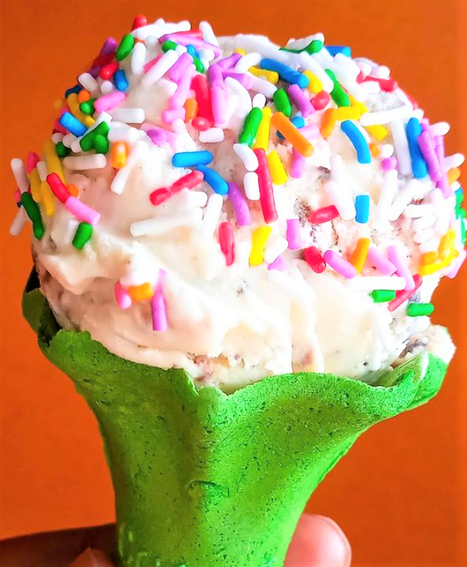

Alex Creamery

Ice Cream, Cakes, Pastries & Desserts

Curepe

more...



PP

**PIZZA**



PP

**CHICKEN**



PP

**DESSERT**

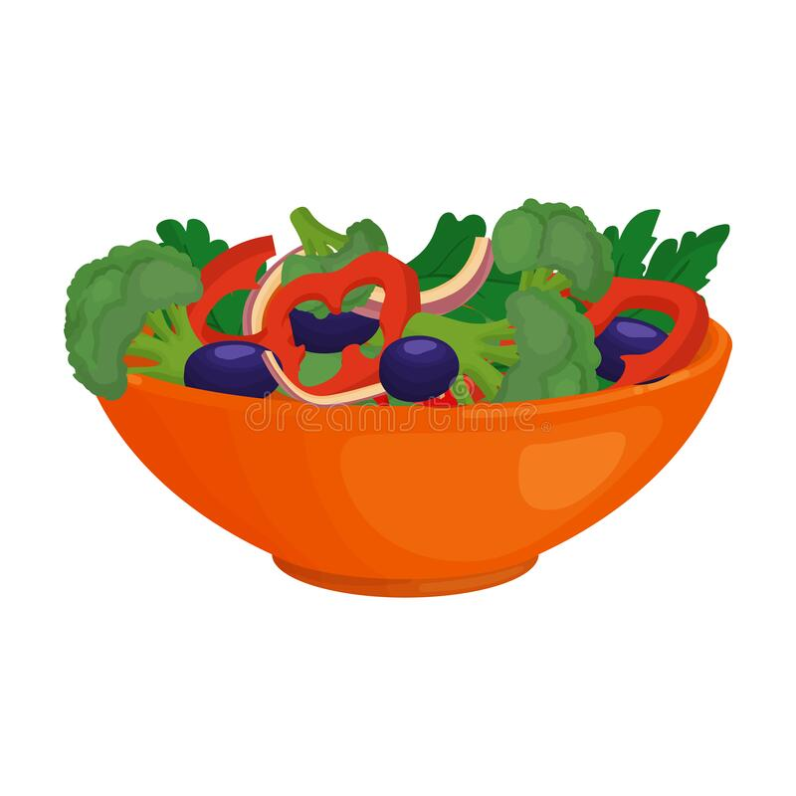

PP

**SALAD**

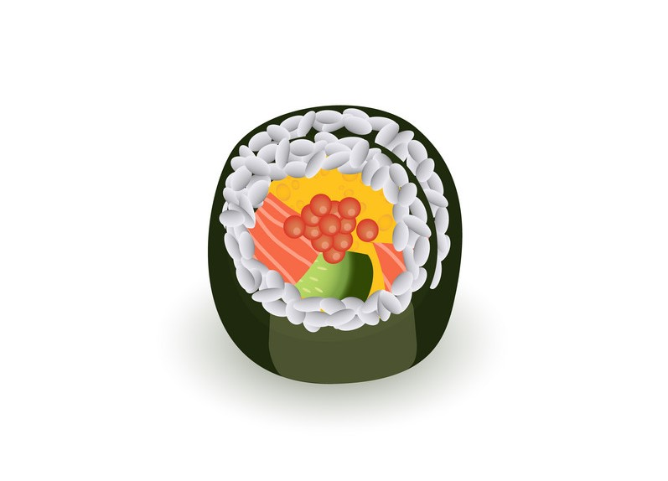

PP

**SUSHI**

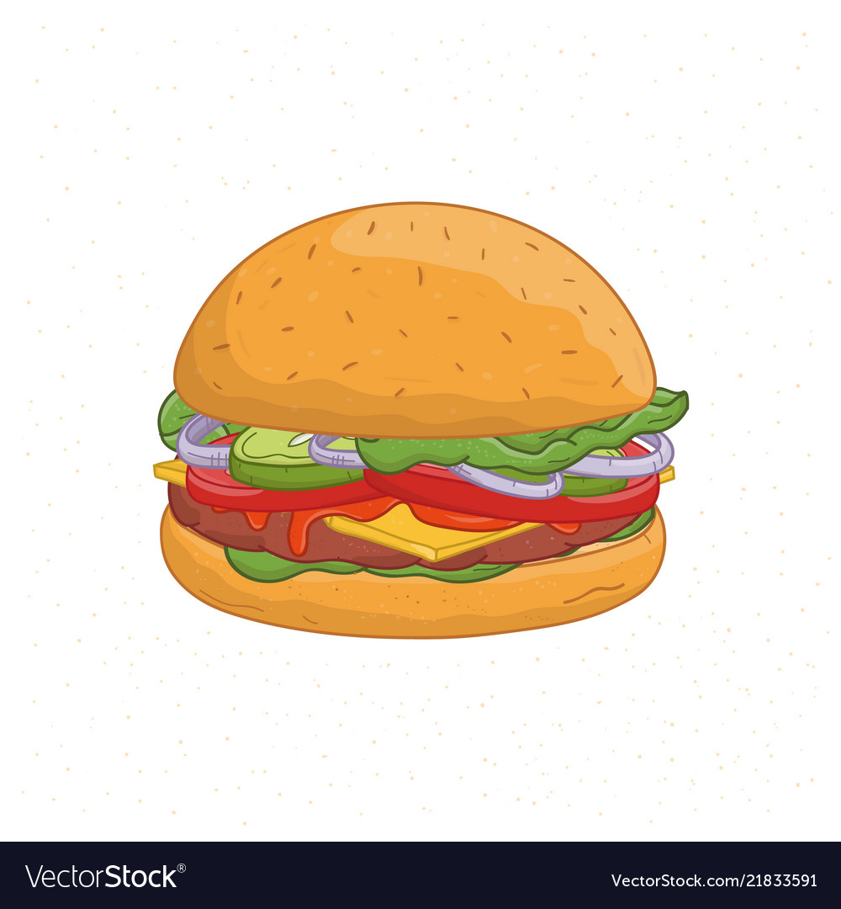

PP

**BURGER**



PP

**ICE CREAM**